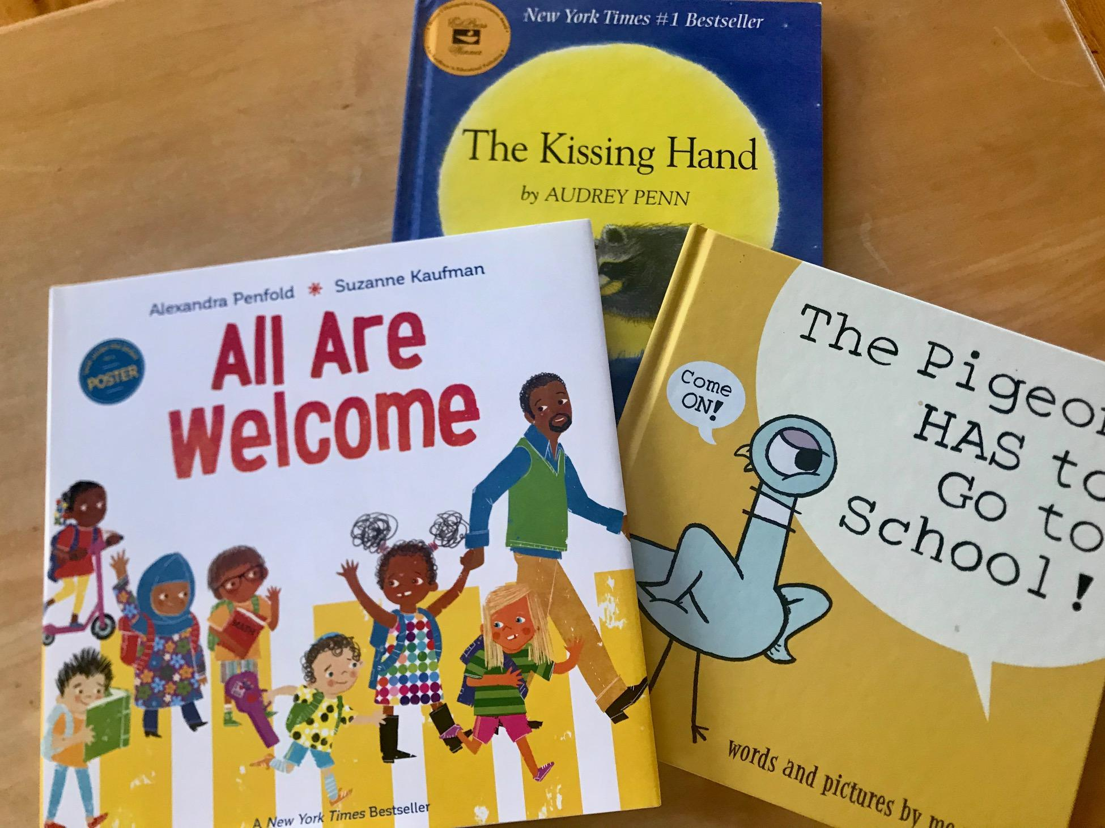
Parent Handbook 2023-2024

Welcome To St. Philip’s Nursery School

This handbook is a guide to help you and your child have a successful preschool experience. We have included some of our most predictable practices and expectations. Please always feel free to speak to a teacher about any concern you may have during the course of the year. Safety is our most important priority.

Mission Statement
The mission of St. Philip’s Nursery School, in partnership with St. Philip’s Episcopal Church, is to provide a vibrant and nurturing preschool experience for the two, three and four -year old children of our community, encouraging them to be active, confident, curious, and well-prepared for further education and lifelong learning.

At St. Philip’s, children gain responsibility and respect for themselves and others, build friendships, and interact cooperatively. Play is at the heart of learning at St. Philip’s. Believing that children learn by doing, teachers encourage students to explore their surroundings, and work with a wide variety of materials to create, build, and experiment. We affirm the uniqueness of each child as we value and support their development intellectually, socially, physically, spiritually, and emotionally. We welcome children of all faiths, ethnicities, socioeconomic backgrounds, and family structures. The Nursery School Committee oversees the Preschool.

Brightwheel

This is the software we use for teacher-parent communication during and after school hours, automatic check in and pick up, picture sharing and also allows for automatic bill-paying. Please get familiar with Brightwheel by loading the app on your phone as well as using it on your computer. Each family should create their own 4 digit code for check-in and check-out.

Calendar

Generally, St. Philip’s has followed a hybrid of the Garrison and Haldane School calendar. For 2023/2024 there will be times when we don’t. We usually end earlier for the December holidays and in June. In addition, there are always some days that are different for Garrison and Haldane and other neighboring school districts. A copy of the calendar is sent to each family; in addition, you can check it on the website: www.stphilipsnursery.org.

Celebrations

We celebrate children’s birthdays in a low-key way; they are special helpers and we sing to them at snack time. Parents usually send in a special snack (anything from fruit to cupcakes). In June, we hold an ice cream sundae party for all children with summer birthdays. PLEASE REMEMBER OUR NUT-FREE POLICY when planning food for school.

We hold a Halloween, Christmas, Valentine’s Day and graduation song and dance recital. We also celebrate Special Person’s Day, Hanukkah, Chinese New Year, St. Patrick’s Day, and any other holiday on request.

Class List

We provide a list of all students’ addresses and phone numbers. Please keep these confidential. Also, please keep us up-to-date with your contact information, so that we can update this sheet.

Clothing at School

Children should arrive dressed for play. All the paint and markers we buy are “washable,” and children wear smocks while painting, but stains and spills sometimes happen. The best clothes for school are comfortable, broken-in items. Pants and sneakers are recommended. For children who are still new to potty-training, we prefer diapers over Pull-Ups. The children will be outside every day when possible, so please dress them in weather-appropriate clothes. Remember hats and mittens in the winter.

PLEASE MARK ALL CLOTHING ITEMS WITH YOUR CHILD’S NAME.

Change of Clothing

Please provide TWO changes of clothes for your child in a labeled Ziploc bag, along with an extra mask (labeled with your child’s name). These are for changing into in the event of accidents. Each child has a cubby, or plastic box. We do have an inventory of clean used clothing if there is nothing in your child’s cubby.

Closings/Cancellations

When snow forces the Garrison School to close, we close.

If Garrison has a two-hour delay in opening, St. Philip’s will have a one-hour delay, opening at 10 a.m. If Garrison closes early, we will use our judgment as to whether we close early or at 12 noon. We will notify you using email and Brightwheel.

School Rules

There are certain school rules that all children will be taught and expected to follow. This is for the safety and well being of everyone. The rulemaking process will be one that the preschoolers will be a part of, in order to help them establish a sense of “belonging” in their new school.

Children learn through making mistakes, and through hearing rules and guidelines repeated over and over again. We try to use just a few rules and to use them positively. “Not hurting others” is a big one. Also: walking feet, indoor voices, watching eyes, listening ears, and helping hands. We explain all these at length to the children at the beginning of school.

Student Expectations

Guidance and Discipline:
In keeping with the mission and Core Values of St. Philip’s Nursery School, our discipline policies guide children in the development of developmentally appropriate social skills. We want each student to grow in kindness, honesty, respect and consideration for others. Teachers carefully plan the classroom environment to encourage and foster peaceful living, cooperation and collaboration. Young children are still learning the problem-solving skills to express their feelings in appropriate ways.

Teachers model sharing, talking about feelings, respect for others and problem solving. We purposefully teach respect, responsibility, kindness, manners and an awareness of the needs and rights of others. Expectations for behavior are clearly delineated and discussed with the students on a regular basis. Cooperative and respectful behavior is praised and kind acts are modeled and noted.

The safety of each child is our highest priority. In our classrooms, conflict can often be deterred with redirection, reminders and the provision of alternate choices. When teachers have established a relationship of trust and respect, they may move an uncooperative child with gentle, verbal encouragement. Children are reminded of previously learned rules and expectations and prompted to respect the needs of others. Sometimes, privileges are withdrawn so they can learn the connection between their actions and logical consequences. Aggressive behavior is stopped immediately and calmly by the teachers and discussed privately with the child or children involved. A young child may be asked to sit quietly to regain self-control and may be removed from the activities of the other children for a short time, but children are never completely isolated from others.

Parental Involvement: Communication with families is at the heart of any guidance program. We welcome communication and initiate both formal and informal conferences. The school and families work together to resolve discipline problems and to plan for guidance. Learning discipline and good decision-making skills is a process. The efforts of the faculty, the parents and the administrators are all important in the creation of an optimal learning environment.

Emergencies

In an emergency, we will try to reach you as quickly as possible by phone or Brightwheel. Please keep us up-to-date with your phone numbers, as well as numbers for trusted friends and relatives. Our plan is to call you as quickly as possible and have you pick up your child from school. If you cannot be reached, we will rely on the alternate contacts provided on the Emergency Form for your child. Please make an Emergency Plan for your family and include your neighbors.

Enrichment Programming

Enrichment Programming is an exciting way to enhance our curriculum. These include in school and out of school activities. Parents may be responsible for the transportation to field trips that are a longer distance away. There may also be fees associated with the trip. Prior to any field trip, parents will be required to sign a permission slip that we will carry (including their emergency form). Teachers also take a fully stocked first aid kit on every trip. If this year we are not able to fit in a field trip, we will have on site enrichment programs for the children.

Projects & Take Home Work

Your child will have artwork and parent handouts from the staff to take home. We will send these home in reusable bags at the end of each week.

Fundraising

SPNS invites families, grandparents and friends to support our school through personal philanthropy and employer matching gift opportunities. An essential prong of compensating talented faculty and covering annual school operational expenses, fundraising is a community endeavor. The School and Church are not-for-profit, and the Church provides our space, insurance, and utilities free-of-charge.

Each family will be solicited annually to participate in some form of giving to the school, at whatever level they are able to give. In recent years, a spring fundraising effort paired with a child-free community-building event have helped advance our mission and fund our programs. The Nursery School also traditionally raises funds through several annual White Elephant or Holiday sales, where community members donate gently used items, baked goods and their time.

Hours

We are a three--hour morning preschool program; (by State law our official hours are 5 minutes less than 3 hours). Our hours are 9:05am - 12pm.

Parents and children are welcome to stay and play on the St. Philip’s playground after school is over.

We understand that things can happen to delay a pickup or drop-off. Please call the Nursery School Director at 845-424-4209 if you are unavoidably delayed. However, if we notice that this begins to become a habit and you are consistently late, we will charge a late fee that we deem appropriate.

Parent Communication

We communicate with parents through phone calls, emails and Brightwheel. Even though parents are not allowed in the school building from 9 to 12, you can make an appointment with Betsy Alberty, Director or any teacher to speak before or after school about questions, concerns, and observations. We will have a Fall Meet the Teacher event, and parent-teacher conferences in the winter and spring as well as whenever you request one. You are your child’s first teachers, and we want to help you as much as possible.

Parent Committee

We are fortunate to have a dedicated committee of parents who organize events to build community, provide parent education, have fun, and assist with fundraising. They communicate directly with you.

Peanut Allergy

We are a NUT FREE school. We have children enrolled who are severely allergic to peanuts and other nuts. We do not use peanut butter or any nut products (and coconut is considered a nut). Please try to think of alternatives on the occasions when you are preparing food for your child at school. If your child has a food allergy, please bring in some safe snacks to keep in the freezer for special occasions.

Personnel

Our teachers are considered essential personnel. In addition, the Reverend Amanda Eiman, her assistant Johnna Locoparra, and our custodian, Marcelo Alarcon are considered essential personnel. No other adults will be in the building during Nursery School hours unless an appointment is made ahead of time.

Playground

We will be outside with the children on most days even with rain and snow. Please dress your child accordingly. And please label coats, mittens, hats, and boots with your child’s name. If you send your child to school in boots please send indoor shoes as well.

You and your children are welcome to stay on our playground after school hours. The safety of the children is everyone’s first priority. The St. Philip’s Parish House parking lot can be busy. If you choose to stay after 12 noon, please keep tabs on your child/children and accompany them if they leave the playground.

If you do bring snacks and lunches for after school, please refrain from serving them until all children have been picked up. All children are hungry after a busy morning and this way we do not have to worry about food allergies, dietary restrictions, or disappointing the children who don’t have treats.

Separation

Generally, children and parents learn to part with few difficulties. Separation can be much more challenging for some children, and we will work with you to make the process as reassuring as possible.

For the first two days of school (Thursday, September 7th and Friday, September 8th) we will end at 11 a.m. to give the children a chance to get accustomed to school.

Signing In and Out/Pick Up Instructions

When you, your spouse, or caregiver bring your child to the front door in the mornings, you will sign in using Brightwheel on our iPad or phone. Brightwheel will give you a code that you or your designated caregiver will use, or a QR code can be used. When you, your spouse, or your caregiver pick up your child at the end of the day, you will repeat the procedure. (We will have a back-up clipboard in case.) If you have any changes or issues, please call the Director at 845-424-4209.

Chapel

The Nursery School is an Episcopal preschool with a nondenominational curriculum. We are a program of St. Philip’s Church in the Highlands. We are fortunate to have with us as a parent, St. Philip’s Rector, the Reverend Amanda Eiman. We will join Amanda once a week in the Church with the Blue Rabbits and Ducks for chapel time, which consists of nondenominational stories and prayers and conversation. The Red Rabbits will meet with Amanda in their classroom downstairs for a short story or songs and only in the chapel once they are mature enough as a group to do so. These sessions will align with themes within the curriculum and lessons on morality.

Dance & Music Class

At St. Philip’s Nursery School, we are lucky to offer both dance and music classes. Our Music Teacher, Micki Lovelady or “Miss Micki”, is trained in the art of dance and teaches our students once a week. Our Music Teacher, Miss. Johanna is trained in reading and performing music with her singing and instrument playing. Dances and songs are taught to our students for 4 Nursery School events each year. We are lucky to impart the love of the arts to our students.

Snack

All groups will have their designated places to eat snack. Teachers will not be sitting with the children, although we will be closeby, and there will be distanced conversation. There is a simple grace before eating or drinking; this is not a long wait but does provide some practice in deferring gratification, which is one of the steps on the road to emotional maturity.

Snack is alternately crackers, graham crackers, pretzels and the like, as well as fruit or vegetables. About once a month, we have a cooking project with the children as well. Children are offered water and based on the holiday juice or milk as well. These will be served by the teachers, and each child will be given their own plate.

Toys Brought to School

No toys from home can be brought into school. We teach the children that all the toys here are for sharing, and, indeed, learning to share is one of the most important things a young child can accomplish. If a child has his or her own toy, other children will want to play with it, which can cause conflict for the toy’s owner.

Having said that, there are some toys that are clear comfort objects, reducing the fear of school for the children who need them. These are usually stuffed animals. We will allow these at the start of school but they will need to be used by the child only in a limited space and on as limited a basis as possible. We recognize that each child is unique and we try to encourage self-confidence so that the need for a comfort object diminishes.

Stuffed animals and dolls are important toys that help children develop their nurturing skills—their emotional intelligence, if you will. We have lots of dolls (although cuddly
animals have been put away), so you can help by reminding your child that we have plenty of fun toys at school.

We have traditionally had some “Show and Tell” days, when children can bring in items and talk about them. These are often theme-related, such as a favorite book. We always welcome nature items, or special family news like a new baby or puppy.

Tuition

Tuition is charged by the term or by the year, and may be paid in monthly installments. Unless other arrangements have been made, tuition is payable on the first day of the month. Payments through Brightwheel are encouraged.

Weapons

We teach peaceful problem-solving, so no toy guns, swords, weapons, or action figures carrying such are allowed at any time. Our message is: “Weapons hurt people, and that’s not good.”

We do remember that young children have played with pretend weapons since time immemorial. There are times when children’s need for a pretend weapon is a signal that something is bothering them; they may be distressed about something and feel the need for a “weapon” to defend them or keep them safe. We will let you know if we notice anything like this.
SAFETY and SECURITY PROCEDURES
Expectations for Parents in Emergency Response Situations
It is common for concerned parents to immediately come to the school in response to an emergency situation. This is a natural parental reaction to the possibility that a child may be in danger. It is important to know that your preschool developed a set of detailed plans to ensure the safety of your child and the general school population. The following information is offered to increase your understanding of these measures and expectations for your response to help St. Philip’s Nursery School staff successfully manage an emergency.

Emergency Response Procedures

Early Dismissal Plan
In the event of an emergency such as those that are weather related, loss of electricity, or lack of water, etc. we will put into place an early dismissal procedure. In these
situations, time permits us to call all parents or emergency contacts to pick up children at the preschool. We will contact you or the person listed on your child’s emergency form. We ask that all parents make sure these phone numbers are updated.

Lockdown
The lockdown is a security procedure used when there is an imminent danger present in the building (intruder, hazardous material) and we want staff and students to remain in the building but out of harm's way. It requires immediate police response to the building and includes:
- Removing all students and staff to designated secured areas;
- Locking doors, turning off lights;
- Taking attendance
- Remaining quiet until an “all clear” is sounded by police or a person in authority.
The lockdown is primarily designed to take all individuals out of harm's way in anticipation of a police response to the scene.

Lockout
The lockout is a security procedure used when there is a potential danger against an individual outside the school or when a danger exists in the vicinity outside of the school. It is used when there is a threat to the school, students and staff from outside the school and when the school is the safest place to be sheltered. It requires an immediate police response and includes consideration of the following actions:

*Limited vehicle access *Increase supervision at arrival and dismissal
*Police presence *No outside recess
*Exterior doors locked and monitored *Windows covered and curtains drawn
*Monitored single point of entry *Limited and controlled visitations

Desired Parent Response: Remain at home to receive updated information. This will be communicated through Brightwheel, email or phone call. The school is functioning in a normal fashion except for outside activities. Staff is on high alert and police are on alert to offer protection and direction. Parents coming to school will complicate the response by school staff and emergency providers.

Sheltering Plan
Sheltering is a security procedure used in response to natural disasters, weather-related, environmental or accident-related emergencies. Variations include:
- In class “duck and cover” procedures in response to surprise weather-related events.
- Evacuation and sheltering to designated areas in the church (corners of sanctuary) with structural integrity.

Evacuation
Evacuation is when students and staff are removed from harm's way, and away from the building. Types of evacuation include walking away from building with staff during a:
- Fire drill, when siren is heard and teachers are expected to follow fire drill procedures;
- Unsafe conditions in the building such as gas leak or water main break.
Students walk away from the building to a designated location such as the Garrison Elementary School.

Desired Parent Response: Wait until the emergency has passed, listen for information about evacuation procedures and follow directions of school or church personnel. This information will be communicated via phone, email, and radio.

Please call the Head of School if you have questions on any issue not addressed in this handbook. Thank you for choosing St. Philip’s for your child’s preschool experience.

